Конспект уроку для дистанційного навчання
Клас – 7
Тема уроку: The Sights of London
Цілі: вдосконалювати лексичні та граматичні навички; вдосконалювати уміння у читанні, аудіюванні й усному мовленні; розвивати логічне мислення і пізнавальний інтерес до вивчення англійської мови, сприяти розширенню кругозору учнів; виховувати зацікавленість у розширенні своїх знань і повагу до культури інших народів.
Обладнання: НМК «Англійська мова 7 кл.» О.Карп’юк, роздатковий матеріал для учнів, доступ до Інтернету, аудіо запис
Procedure
- Warming up
Dear, children! Let’s play. Please, have a look at these pictures. These are London and Kyiv. Your task is to name as many things as come to your mind according with these two capitals.

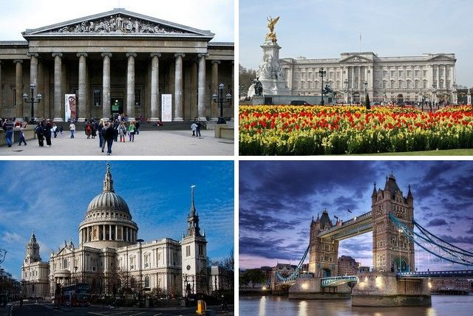
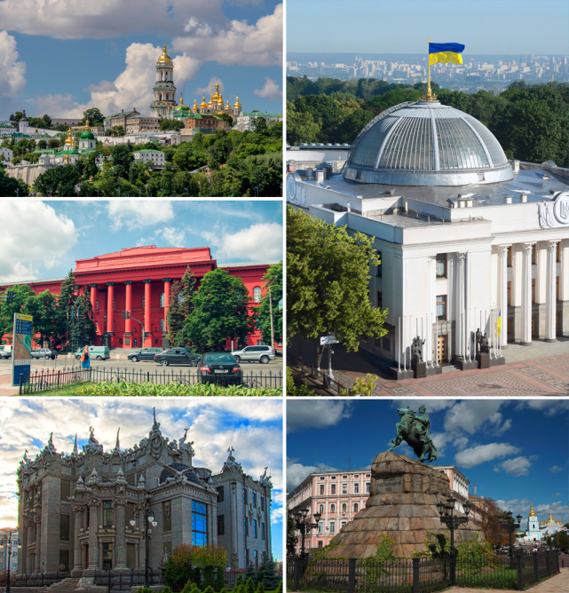
- Checking the home task.
What is the best place for you to relax: at home or abroad? Try to explain why

- Vocabulary Practice
Find the new words from p. 167 in ex. 7, p. 169-170 and translate the sentences with them. Then write your own sentences with the new words.

- Listening
Pre-listening activity
Let’s play “Guess what sights is it?”
- This charming cathedral was built by Sir Christopher Wren after the Great Fire of London.
- This museum has a collection of mummies, tomb, paintings and gold jewellery from Ancient Egypt.
- It has a large collection of birds and animals from all over the world.
- There you’ll see realistic, life-size wax figures of famous people.

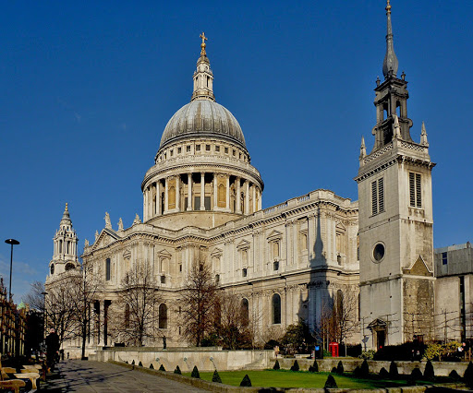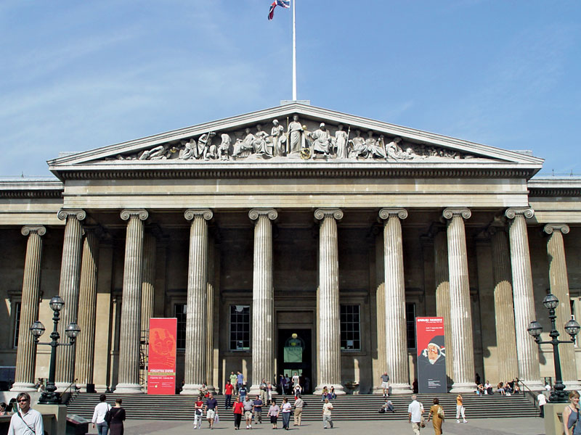

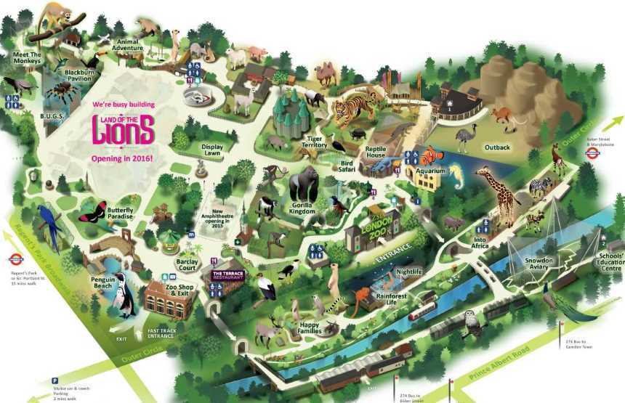
While-listening activity
Listen to the text and number the places below in the order they mention them
( Ex. 3 p. 163) (Слухай додаток 1)
Post-listening activity
What places of interests in London do you want to visit? Create a puzzle using the name of your favorite sightseeing.
- Speaking
Have you ever visited the famous places of London? Make up sentences.
We  They  He  She | haven’t | already | visited | St.Paul’s Cathedral | yet
 | have |  |  | the Houses of Parliament
 | hasn’t |  |  | the Royal Observatory in Greenwich
 | has |  |  | Downing Street

- Reading
Pre-reading activity
Do you like to go to the park? Where do you think, is an amazing view of the city?

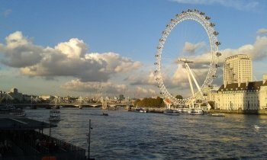
While-reading activity
The British Airways London Eye, sometimes called the Millennium Wheel, is the first-built and largest observation wheel in the world since the end of 1999. It is 135 meters high. The wheel has 32 closed and air conditioned passenger capsules. It moves at about 0.9 kilometers high so that one round take about 30 minutes. The wheel does not usually stop to take on passengers; the movement is so slow that passengers can easily walk on and off moving capsules. But it is stopped to give disabled or elderly passengers time to get off safely. Since it opening, the Eye has become one of the main tourist attractions.
Post-reading activity
Match what things/dates/ facts these numbers refer to?
a. 1999 1.Meters high
b. 32 2. The London Eye was build.
c. 0.9 3. It moves at about kilometers high
d. 30 4. Closed and air conditioned passenger capsules
e. 1000 5.Minutes takes one round
f.135 6.Millennium

- Let’s have fun and rest. Listen to the song about London Bridge and relax a bit.
https://www.youtube.com/watch?v=qsvdwj3aOfY&list=PLRhHC9N5rKQL7rfi1_tC5FGiJNsfZAWNR

- Grammar
Watch a video to refresh knowledge about Past Simple, Past Continuous and Past Perfect Tenses.
https://www.youtube.com/watch?v=_KRRUPj1IGg
Now, to practice your skills, do ex. 3 p.166.

- Summary
Write a letter to your pen friend about one of the places of interest in London.
Розробник: творча група вчителів англійської мови м. Суми

